Student Handout

**Decoding the Preamble Puzzle**

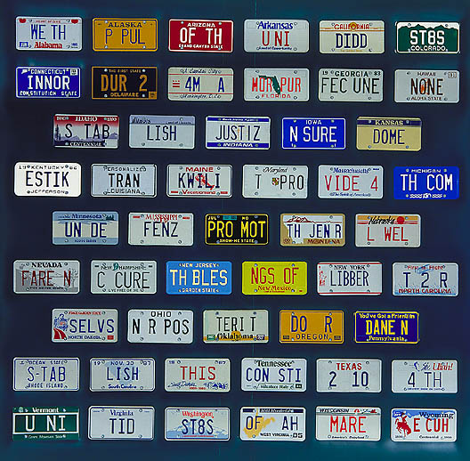

~ *Preamble* by Mike Wilkins

**Directions:**

The picture above is an artistic version of the Preamble to the U.S. Constitution. Look carefully and then translate this picture to determine the actual words of the Preamble.

**____________________________________________________________________________________________**

**____________________________________________________________________________________________**

**____________________________________________________________________________________________**

The Preamble outlines six (6) functions of the U.S. government created by the Constitution. What are they?

**1. 2. 3.**

**4. 5. 6.**

**What Does Government Do?**

**The Preamble to the Constitution**

*“We the People of the United States, in Order to…*

|  |  |
| --- | --- |
| **Form a more perfect union**  MPj03628600000[1] | examples: |
| **Establish justice**  MCj02171980000[1] | examples: |
| **Insure domestic tranquility**  MCj02956560000[1] | examples: |
| **Provide for the common defense**  MCj02327290000[1] | examples: |
| **Promote the general welfare**  MCj02324310000[1] | examples: |
| **Secure the blessings of liberty to ourselves and our posterity**  MCj03320280000[1] | examples: |

*…do ordain and establish this Constitution for the United States of America.”*