Unit 1 Exam Study Guide

Chapters 1 - 2

Definitions - Define the following terms
For nations, where did they explore/colonize?
Silk Road
Slaves
French
Slave Trade
Spain
San Salvador
Colonization
English & Dutch
Columbian Exchange

Questions
- What did the varied landscapes of North America encourage?
- Describe West African trade routes
- The densest areas of Native American populations tended to be around what?
- What issues did Native Americans have with European diseases?
- When demand for workers grows, the price for slaves does what?
- What did Puritans believe?
- What did Native Americans in the 1490s do?

Chapter 3

Definitions - Define the Following Terms
Middle Passage
Women
French and Indian War
The Great Awakening
World powers
Proclamation of 1763
The Enlightenment
Africans
Treaty of Paris

Questions
- In what areas/trades did slaves work in the South?
- What is an indentured servant?
- What did the colonies provided England with?
- What did the South develop?
- What items were seized from the accused during the Salem witch trials?
- Where did France explore, beginning its North American empire in 1534 ?
- When do colonists begin to see the British as vulnerable?
- What did British troops send to the Native Americans in retaliation for their attacks on the forts west of the Appalachian Mountains?

Reading A Map
Be able to answer questions about this map:
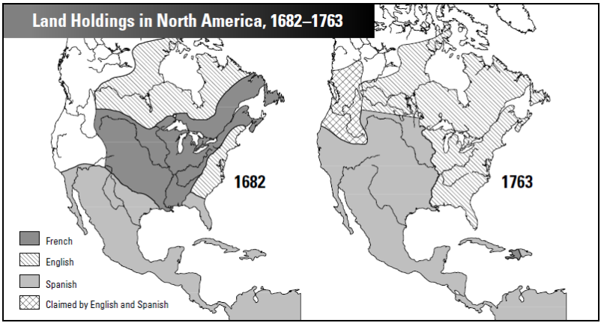

Chapter 4

Define
Second Continental Congress
Stamp Act
Battle of Bunker Hill
Loyalist
Egalitarianism
Declaration of Independence
Patriot
Thomas Paine
Thomas Jefferson
John Locke
Townshend Acts
Boston Massacre
Battle of Trenton
Treaty of Paris

Questions
- What were Paul Revere’s real warning words?
- Name the things the Patriots did when they declared Independence?
- What is included in the Declaration of Independence:
- What group chose not to fight, but supported the Patriot cause?
- What group viewed the colonists as a bigger threat than Britain?
- During the Revolution, what did African Americans do?
- What did France fear?
- The 1782 peace talks included which countries?

Document Analysis
You will read two documents, answering these questions:
Who created this document?
Why might they create this document? (What is the purpose?) When was it written?
What else was going on at the time that this was written?
You will finish this sentence. The authors are trying to convince me….

Short Answer
You will be graded using the following rubric for each question.
Use: Introductory sentence & conclusion, complete sentences & paragraphs! If you run out of room or like to write large, use a separate sheet of paper. Remember to back up your arguments with evidence!
 | 5 | 6 | 7 | 8
Analysis | - Descriptive, not analytical  - Marginally related to the topic  - Significant logical gaps | - Addresses most parts of topic  - Adequate, but unevenly developed | - Good analysis of the topic  - Addresses most parts of the topic  - Demonstrates understanding of all sides of a question (as appropriate)  - Unevenly developed | - Persuasive analysis of topic  - addresses all parts of topic  - demonstrates thorough understanding of all sides of a question (as appropriate)
Historical Issues | - Little grasp of general historical issues raised by topic | - Some grasp of general historical issues raised by topic  - Significant issues may be omitted | - Good grasp of general historical issues raised by topic | - Outstanding grasp of general historical issues raised by topic
Relevant History | - Few and/or erroneous specific examples  - Demonstrate little knowledge of relevant history | - Some specific examples demonstrate knowledge of relevant history  - Some clearly relevant examples omitted | - Several specific examples  - Demonstrate good knowledge of relevant history | - Numerous specific examples  - demonstrate detailed knowledge of relevant history
Organization | - Poorly organized  - No clear introduction, argument or conclusion | - Unclear  - Missing introduction, argument or conclusion | - Well organized  - Introduction, argument, conclusion present | - Well written  - Appropriate standard English
Sources & Citations | - Does not use sources  - Only minimally uses sources provided by instructor  OR  - Relies exclusively on non-scholarly sources  - No in text citations  - No attempt is made to cite evidence | - Uses only a few sources  - Doesn’t go beyond what has been provided by instructor  - Factual statements infrequently cited in text  - Some pieces are not cited or inaccurately cited | - Many sources  - Relies heavily on a more limited set  - Factual statements frequently cited in text | - Wide range of sources  - In text citations used  - Factual statements cited

What caused the Salem Witch Trials?
Where the Puritans selfish or selfless?
Why did some colonists choose to remain loyal to the British?

What caused the American Revolution?
Write the Declaration of Independence in your own words.
What ideas or symbols did Stamp Act Protest images use? Why?
Would the revolution have happened if King George had accepted the Olive Branch Petition? Back up your answer with historical facts.
What were the causes of, ideas in, and results of the writing of the Declaration of Independence?
Explain why the founders wrote the Declaration of Independence. Be sure to elaborate on what their motivations were.

